Desk Number ________

Student Number _______________________

Student Name _______________________

**School of Science and Engineering**

**FINAL EXAMINATION**

Semester 2, May, 2020

**CSC1001 Introduction to Computer Science:**

**Programming Methodology**

Examination Duration: 120 minutes

Reading Time: 10 minutes

This examination has __3__ questions.

**Exam Conditions:**

This is a FORMAL Examination

This is a RESTRICTED OPEN BOOK Exam. Maximum of one (1) sheet of notes double sided are permitted

**Materials Permitted In The Exam Venue:**

Maximum of one (1) sheet of handwritten notes double sided are permitted. **NO OTHER MATERIALS PERMITTED**

Any calculators without the functionalities of programming and file storage are permitted.

**Materials To Be Supplied To Students:**

1 × 9 Page Answer Booklet

Question 1. (10 × 3% = 30%)

Pick the correct option in each of the following sub-questions. Note that only ONE option is correct.

* 1. Binary number 10011010.001 and hexadecimal number 2B3.8 equal to decimal numbers: A

1. 154.125 and 691.5
2. 154.125 and 707.5
3. 308.25 and 691.5
4. 308.25 and 707.5
   1. Concerning Python language, which of the following statements is correct? D
5. The python interpreter is only a tool to check grammar mistakes of python code.
6. Object-Oriented Programming is a unique feature of Python.
7. Python source files may use any extensions.
8. Python is a cross-platform language: Pythons programs written on Windows can also run on Linux and macOS.
   1. Concerning the following program, which of the following statement is incorrect? B

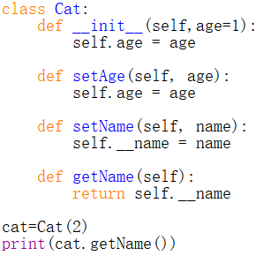

1. The __init__() function can be invoked out of the definition of class Cat.
2. The __init__() function is a private method.
3. The attribute self.__name in class Cat is private.
4. The statement print(cat.getName()) will raise an error.
   1. Concerning the following program, which of the following statements is incorrect? C

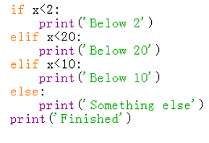

1. print(‘Below 2’) will be executed when $x=1$.
2. print(‘Below 20’) will be executed when $x=10$.
3. print(‘Below 10’) will be executed when $x=8$.
4. print(‘Something else’) will be executed when $x=20$.
   1. Concerning the following program, which of the following statements is incorrect? C

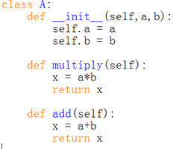

A. Class A() contains two newly defined data fields.

B. The scope of self is throughout the whole body of class A().

C. Method add() will return the sum of two data fields a and b.

D. Variable x defined in multiply() and add() are two different local variables.

* 1. Concerning the object in Python, which of the following statements is incorrect? B

1. Every object in Python has an unique ID.
2. The type of an object cannot be determined automatically by Python interpreter, programmer must define its type.
3. Every variable is essentially a reference to an object.
4. The ID of an object will not be changed during the execution of the program.
   1. Concerning class inheritance in Python, which of the following statements is incorrect? C
5. Inheritance enables you to define a general class and later extend it to define more specialized classes.
6. A subclass may inherit data fields and methods from its superclass.
7. Every instance of the superclass is also an instance of the subclass.
8. A subclass is not a subset of its superclass, usually it contains more information and methods than its superclass.
   1. Concerning the following program, which of the following statements is correct? D

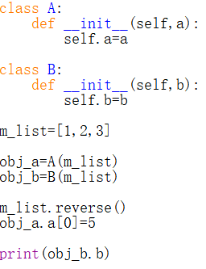

1. The output of the statement print(obj_b.b) is [1, 2, 3].
2. The output of the statement print(obj_b.b) is [5, 2, 3].
3. The output of the statement print(obj_b.b) is [3, 2, 1].
4. The output of the statement print(obj_b.b) is [5, 2, 1].
   1. Concerning data structure and algorithm, which of the following statements is incorrect? A
5. When evaluating an algorithm, we only need to measuring its running time.
6. Data structure concerns how to organize and access data.
7. An algorithm is a step-by-step procedure for performing some tasks in a finite amount of time.
8. When analyzing the running time of an algorithm, two commonly used approaches are experimental analysis and theoretical analysis.
   1. Concerning the binary search algorithm, which of the following statement is correct? A
9. This algorithm is able to find out whether a target element exists in a given sequence of elements.
10. Binary search algorithm can be applied on an unsorted sequence.
11. The time complexity of binary search is O(n).
12. Binary search is usually equally efficient compared with sequential search.

Question 2. (10 × 4% = 40%)

Pick the correct option/s in each of the following sub-questions. Note that there may be MULTIPLE correct options for each sub-question. You will get 2 points when your answers are partially right.

1. Concerning the following program, which of the following statement/s is/are correct? BD

1. Class B() has only one superclass.
2. In class B(), the initializer of A() is accessed by calling function super().__init__(2021).
3. Class B() has only one data field.
4. The output of b.i and b.j are 2022 and 1.
5. Concerning the class in Python, which of the following statement/s is/are correct? ABD
6. In Python, class and data type are equivalent.
7. A subclass can inherit or override the public data fields and methods of its superclass.
8. We cannot access private members both in and outside the class.
9. The scope of a local variable in a method is within this method, we cannot access it outside the method.
10. Which of the following statements is/are correct? ABD
11. Data are saved sequentially in a queue.
12. A singly linked list is also a tree.
13. A tree is also a linked list.
14. Stack and queue can be implemented based on linked list.
15. Concerning the binary search algorithm, which of the following statement/s is/are correct? CD
16. Binary search algorithm can be applied on an unsorted sequence.
17. The time complexity of binary search is O(n).
18. The time complexity of binary search is O(log n).
19. Binary search is usually more efficient than sequential search.
20. Concerning linked list, which of the following statement/s is/are correct? BC
21. For a singly linked list, each node has two references except for tail.
22. We can identify the tail of a singly linked list as the node having None as its next reference.
23. The time complexity of inserting a node at the tail of a singly linked list is constant.
24. The time complexity of removing a node at the tail of a singly linked list is constant.
25. Concerning a binary tree, which of the following statement/s is/are correct? ABD
26. In a binary tree, each node contains three references.
27. Each child node is labelled as being either a left child or a right child.
28. A binary tree is proper if each node has either one or two children.
29. In a binary tree, data are saved hierarchically.
30. Concerning stack, which of the following statement/s is/are correct? AD
31. A stack can be accessed based on the “last in first out” principle.
32. More than one element of a stack can be accessed simultaneously if necessary.
33. The time complexity of Inserting an element into a stack is linear.
34. The time complexity of removing an element from a stack is constant.
35. Concerning algorithm analysis, which of the following statement/s is/are correct? AC
36. The big-Oh notation allows us to say that a function f(n) is less than or equal to another function g(n) up to a constant factor when n is large enough.
37. Function $5n^{4}+6n^{3}+2n^{2}+2^{n}+2n$ is O($n^{4}$).
38. The big-Oh notation can be used to characterize the running time of an algorithm in the asymptotic sense.
39. When we analyze an algorithm, we are usually interested at its average performance regardless of the input size.
40. Concerning recursion, which of the following statement/s is/are correct? A
41. Calculating factorial function belongs to linear recursive algorithms.
42. A recursive definition should have only one base case.
43. Inside a function, only one recursive call can be made.
44. Quick sort is a recursive algorithm whose average time complexity is O(n2).
45. Assume that the five numbers 1, 2, 3, 4, and 5 are pushed onto the stack, which of the following statement/s is/are correct?: CD
46. If the numbers are pushed in the order of 1-2-3-4-5, then the first number popped will be 1.
47. In Python, these five numbers are essentially saved in a list.
48. The stack can be implemented based on a dictionary.
49. The time complexity of popping out all elements in the stack is O(n).

Question 3. (8% + 10% + 12% = 30%)

Read the following programs and answer the corresponding questions.

* 1. Concerning the following program.

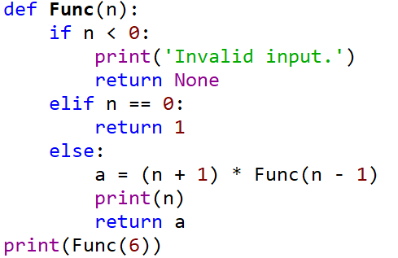

1. How many times function Func() will be called in total？
2. What are the outputs of this program?

**Answer:**

1) 7 3 points

2) 5 points



* 1. Concerning the following program

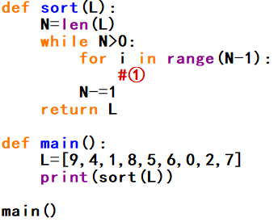

Answer the following questions:

1. This program is to sort a given list with descending order (the output of the above program is [9, 8, 7, 6, 5, 4, 2, 1, 0]). Use bubble sort to implement the sort. Please fill the blank ① to complete the program(maybe more than one line of code are needed.)
2. What is the time complexity of bubble sorting algorithm?

**Answer:**

1) 6 points

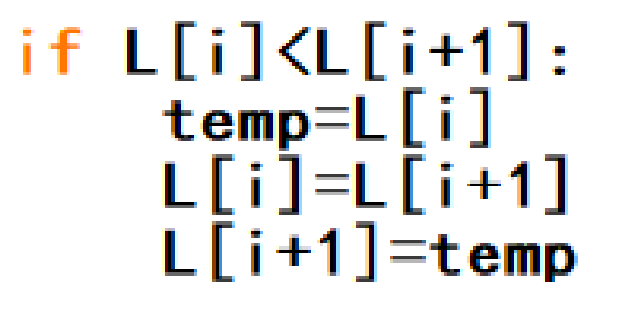

2) O(n2) 4 points

* 1. Concerning the following program, and assume that input t will be a reference pointing to the root of a binary tree.

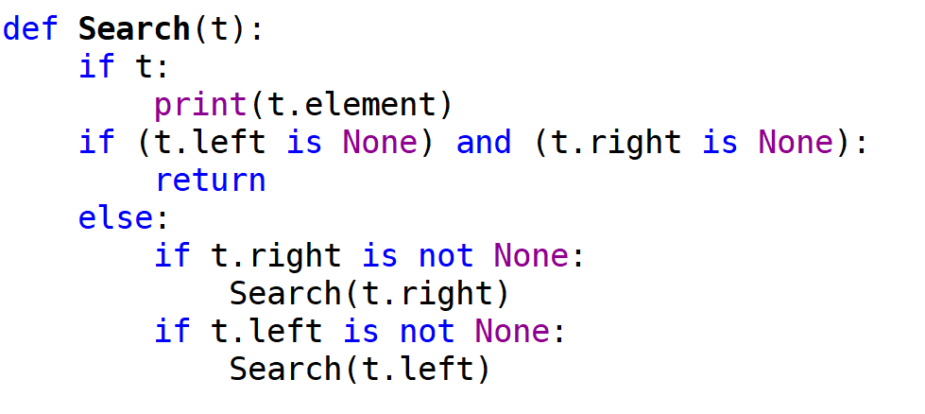

Answer the following questions:

1. Which algorithm is implemented in this function?
2. What is the time complexity of this algorithm?
3. Is this function a linear recursive or multiple recursive function?
4. If input t is referencing to the root of the following tree, what would be the outputs of this function?

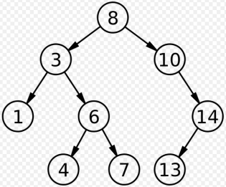

**Answer:**

1) Depth First Search 3 points

2) O(n) 3 points

3) multiple recursive function 3 points

4) 8 3 points

10

14

13

3

6

7

4

1

**END OF EXAMINATION**